LAB 11
(Total Marks 15+3=18)

Task 1: Write the program that count the number of spaces in given string using SCAS instruction and display the counter on screen
- Determine the length of a string using the null terminator.
- Only use SCAS instruction
- Message: db 'Ass em bly lan gua ge', 0 counter: 5
- Use your full name in message and put space after two alphabetics. …
[org 0x0100]
jmp start
message: db 'ra fa y ad ee l', 0 ; null terminated string

clrscr: push es
push ax
push cx
push di
mov ax, 0xb800
mov es, ax
xor di, di
mov ax, 0x0720
mov cx, 2000
cld
rep stosw
pop di
pop cx
pop ax
pop es
ret

strlen: push bp
mov bp,sp
push es
push cx
push di
les di, [bp+4] ; point es:di to string
mov cx, 0xffff ; load maximum number in cx
xor al, al ; load a zero in al
repne scasb ; find zero in the string
mov ax, 0xffff ; load maximum number in ax
sub ax, cx ; find change in cx
dec ax ; exclude null from length
pop di
pop cx
pop es
pop bp
ret 4

count_space:
push bp
mov bp, sp
push es
push ax
push cx
push si
push di
push ds ; push segment of string
mov ax, [bp+4]
push ax ; push offset of string
call strlen
cmp ax, 0 ; is the string empty
jz exit ; no printing if string is empty
mov cx, ax
mov dl,0

push ds
pop es ; load ds in es
mov di, [bp+4] ; point di to string
counting:
mov ax,0x0720 ; load a zero in al
scasb ; find zero in the string
jne skip
inc dl
skip:
loop counting

mov ax, 0xb800
mov es, ax
mov al,dl
mov ah,73
add ax,0x30
mov di,0
mov word[es:di],ax
jz exit

exit: pop di
pop si
pop cx
pop ax
pop es
pop bp
ret 2

start: call clrscr
mov ax, message
push ax
call count_space
mov ax, 0x4c00
int 0x21
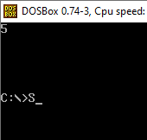
Task 2: Write a code for scroll down behavior of the screen. This will require an input of how many numbers of lines being needed to be scrolled up as a parameter and then you will use “Movs” to scroll down.

[org 0x0100]
jmp start

scrolldown: push bp
mov bp, sp
push ax
push cx
push si
push di
push es
push ds
mov ax, 80
mul byte [bp+4]
push ax
shl ax, 1
mov si, 3998
sub si, ax
mov cx, 2000
sub cx, ax
mov ax, 0xb800
mov es, ax
mov ds, ax
mov di, 3998
std
rep movsw

pop cx
mov ax,80
mov bx,[bp+4]
dec bx
mul bx
add cx,ax
mov ax, 0x072A
rep stosw
pop ds
pop es
pop di
pop si
pop cx
pop ax
pop bp
ret 2

start: mov ax, 3
push ax
call scrolldown
mov ax, 0x4c00
int 0x21
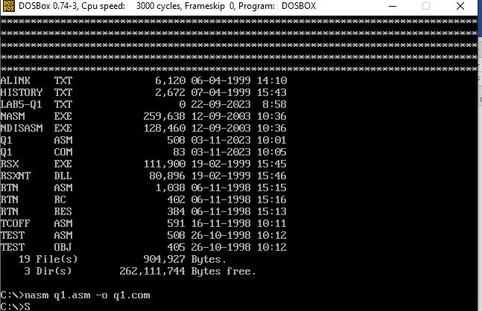
Task3: Write a program for substring search (that searches for a substring within a given string) The program should return the 1 if the substring is found, or 0 if the substring is not found.
- Use Cmps instruction
- Use ax register for returning value
- i.e message string: db 'hello world’
- search: db ‘world’
- Use your full name in message string and once find first name in message string and then search wrong name.
[org 0x0100]
jmp start
string1: db 'rafay adeel', 0
string2: db 'adeel’,0
string3: db 'olalalalala', 0

clrscr:
push es
push ax
push cx
push di
mov ax, 0xb800
mov es, ax
xor di, di
mov ax, 0x0720
mov cx, 2000
cld
rep stosw
pop di
pop cx
pop ax
pop es
ret

strlen:
push bp
mov bp, sp
push es
push cx
push di
les di, [bp+4]
mov cx, 0xffff
xor al, al
repne scasb
mov ax, 0xffff
sub ax, cx
dec ax
pop di
pop cx
pop es
pop bp
ret 4

string_compare:
push bp
mov bp, sp
push cx
push si
push di
push es
push ds
lds si, [bp+4] ; string 1
les di, [bp+8] ; strign 2
push ds
push si
call strlen ; length string 1
mov bx, ax
push es
push di
call strlen ;length string 2

start_compare:
cld
mov cx, ax
repe cmpsb
je equal
les di, [bp+8]
jcxz start_compare

exit_false:
mov ax, 0
jmp exit
equal:
mov ax, 1
exit:
pop ds
pop es
pop di
pop si
pop cx
pop bp
ret 8

display:
mov bp, sp
mov bl, al
add bl, 0x30
mov bh, 0x07
mov ax, 0xb800
mov es, ax
mov word [es:di], bx
ret

start:

push ds
mov ax, string2
push ax
push ds
mov ax, string1
push ax
call string_compare

mov di, 2000; middle of string
call display

mov ax,0
push ds
mov ax, string3
push ax
push ds
mov ax, string1
call string_compare

add di, 4
call display

mov ax, 0x4c00
int 0x21
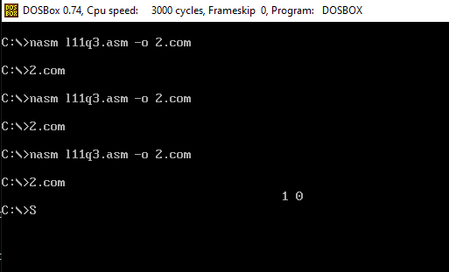
Best of luck

